Title: Secure Chat Application - Week 3 Deliverable
1. Introduction
This document outlines the implementation of server-side components, user authentication, and message handling for the secure chat application.
2. Server-Side Components
Description: The server-side components were implemented using Node.js, Express, and MongoDB. The server connects to a MongoDB database and provides endpoints for user authentication and message handling.
Here’s the screenshot of MongoDB and node.js running
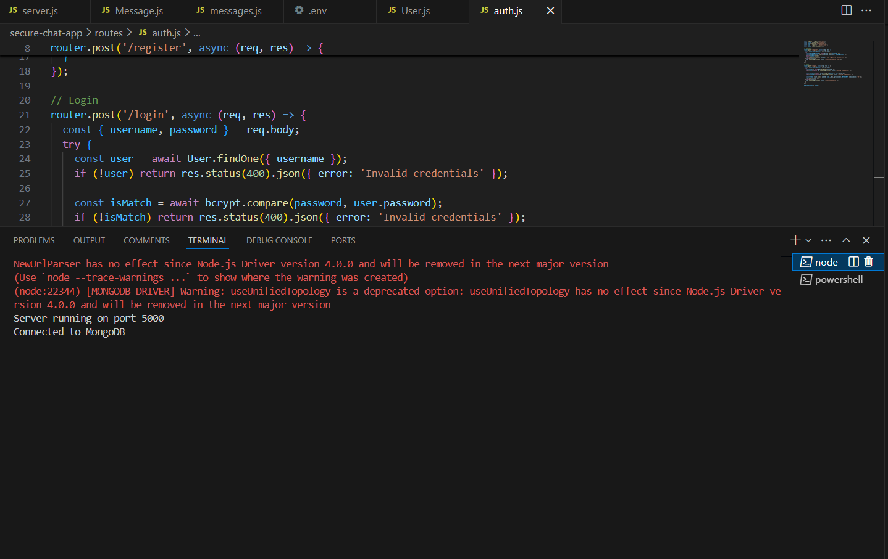

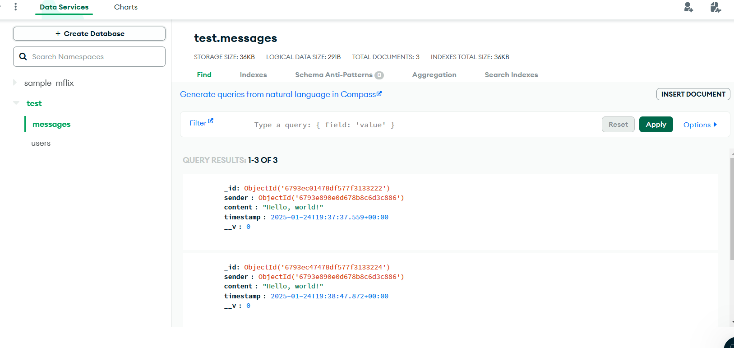

3. User Authentication
Description: User authentication was implemented using bcrypt for password hashing and JWT for token generation. The authentication routes include user registration and login.

User registration: 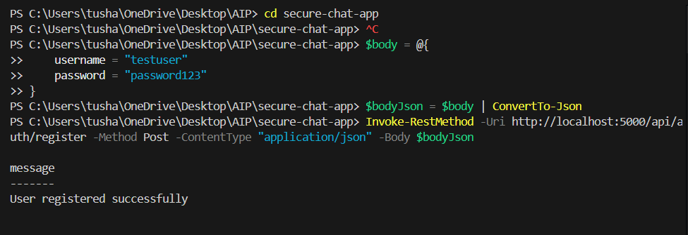

User login and token generation:
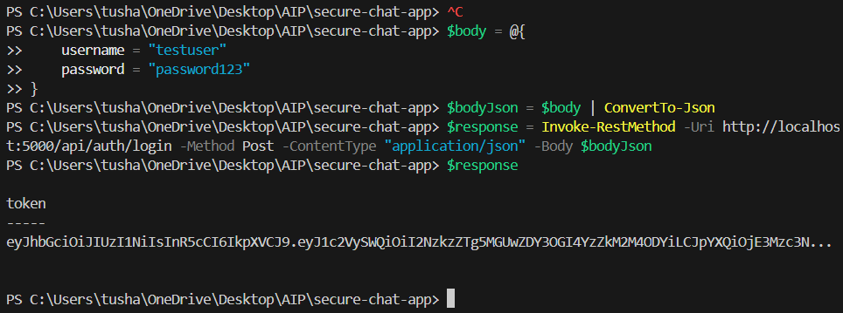

4. Message Handling
Description: Message handling was implemented using Mongoose models for storing messages and Socket.io for real-time communication.
Message Handling: 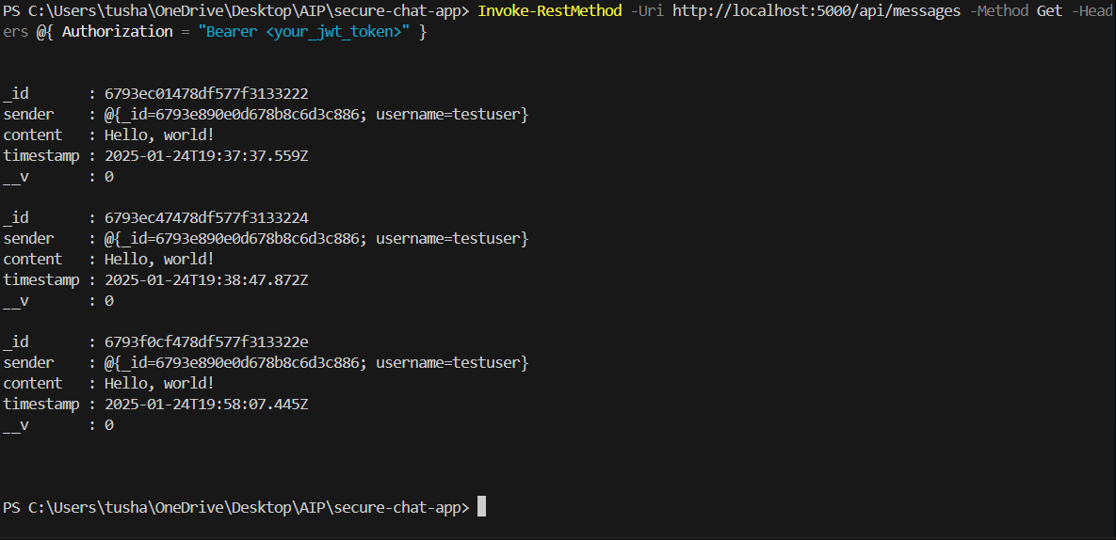

Conclusion
The implementation of server-side components, user authentication, and message handling for the secure chat application was successfully completed and tested.

